Patients With COVID-19 Have Distinct Markings in Their Lungs, New Study Finds
Mar 10, 2020 | Featured, Infectious Diseases, Research |

Patients in China with COVID-19 showed distinct patterns in their lungs that became more defined within a few of days of disease onset, according to two cardiothoracic radiologists at the Mount Sinai Health System, who were the first in the nation to examine the CT scans of Chinese patients with the coronavirus.
The radiologists, Michael S. Chung, MD, and Adam Bernheim, MD, from the Icahn School of Medicine at Mount Sinai, say the distinct markings of these 121 patients offer objective evidence that could help doctors diagnose COVID-19 within minutes. The CT scans would support the health care community’s work in determining who has the disease and its ability to quickly isolate and treat patients. The test swabs being used to confirm the disease in patients can take up to 12 hours to process.
In a study that appeared in the February issue of Radiology, Drs. Chung and Bernheim described the disease characteristics of patients at four hospitals located in four different provinces in China. The patients were between the ages of 18 and 80, and their cases ranged from mild to severe. Of the patients who were scanned within two days after reporting symptoms, more than half showed no evidence of lung disease. Patients who were scanned three to five days after reporting symptoms showed distinctive patterns in their lungs.
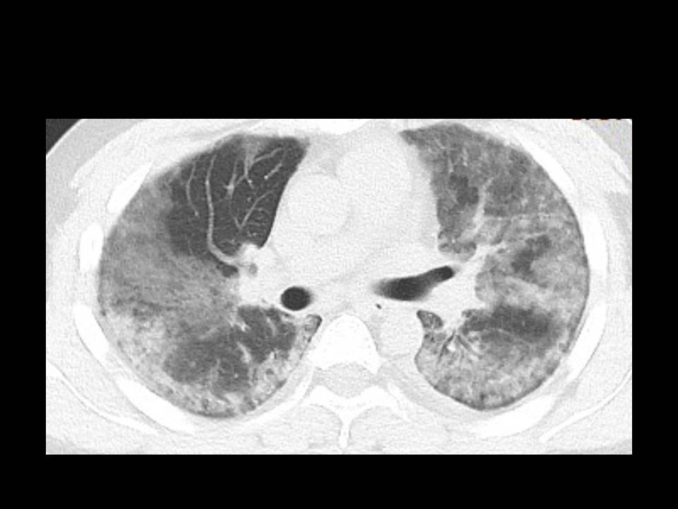
A 29-year old male with unknown exposure history, presenting with fever and cough and requiring admission to the intensive care unit. The CT image shows diffuse bilateral confluent and patchy ground-glass and consolidative pulmonary opacities, with a striking peripheral distribution in the right lower lobe.
1234
Dr. Chung, the study’s senior author, is an Assistant Professor of Diagnostic, Molecular and Interventional Radiology, and Medicine (Cardiology). Dr. Bernheim, the first author, is an Assistant Professor of Diagnostic, Molecular and Interventional Radiology. According to the authors, “Prompt recognition of the disease is invaluable to ensure timely treatment, and from a public health perspective, rapid patient isolation is crucial to containment of this communicable disease.”
The doctors say CT imaging is an efficient tool that is generally available throughout the world, even in places with more limited resources. The established imaging patterns of COVID-19 will provide doctors with the evidence they need to look for when making a diagnosis.
Early in the disease phase, the radiologists described a look of “ground-glass abnormality,” in the lungs. As the disease progressed, it was followed by what they called a look of “crazy paving,” which was followed by “increasing consolidation.” This imaging road map, they say, will help physicians predict disease progression and the development of complications.
For physicians, the most critical element in the severity of COVID-19 is the degree to which the lungs fill with fluid, with the worst outcome being the patient succumbing to pneumonia.
“The normal lung is black because it’s composed of air,” says Dr. Chung. “But in a patient with COVID-19 or another severe pneumonia, those areas become filled with cells, debris, pus, and fluid, and become white. That is a diseased lung that is not aerating, not exchanging oxygen and carbon dioxide. If it’s extensive enough and severe enough, and the body’s inflammatory response and immune system’s response can also cause downstream complications at the cellular level, that would make it difficult to oxygenate and could become fatal.”
Why some patients have more severe cases of the disease than others is still unknown, says Dr. Bernheim. He says that even though COVID-19 is in the same viral family as the SARS and MERS coronaviruses and “probably affects the lungs the same way, we are treating this as a new entity. We will have to see how it changes, progresses, and resolves, and treat it as a new area of research as opposed to just comparing it to SARS and MERS.”
Drs. Chung and Bernheim worked with Zahi Fayad, PhD, and his team at the Icahn School of Medicine at Mount Sinai’s newly renamed BioMedical Imaging and Engineering Institute, which creates novel imaging programs and medical technology. Dr. Fayad is the Institute’s Director.
https://inside.mountsinai.org/blog/patients-with-covid-19-have-distinct-markings-in-their-lungs-new-study-finds/

